
COMMONWEALTH of VIRGINIA
Department of Health
B. Cameron Webb, MD, JD P O BOX 2448 TTY 7-1-1 OR
State Health Commissioner RICHMOND, VA 23218 1-800-828-1120

September 1, 2026

Mr. David Simon
Product Specialist
Valencia Pipe Company

Dear Mr. Simon,

On June 19th, 2026 you submitted documentation on the following septic tanks for approval by the Virginia Department of Health, Office of Environmental Health, Division of Water and Wastewater Services.

Model Number | Description
87-750LO-G-2-2 | 750 gallon low profile dual compartment septic tank
87-1000LO-G-2-2 | 1000 gallon low profile dual compartment septic tank
87-1250LO-G-2-2 | 1250 gallon low profile dual compartment septic tank
87-1500LO-G-2-2 | 1500 gallon low profile dual compartment septic tank

The subject tanks do not meet the following Sewage Handling and Disposal Regulations (12VAC5-610-815) criteria:
1-2 inch difference between inverts of inlet and outlet structures (3 inches provided)
4-8 foot liquid depth (40 inches provided)
Minimum 12 inches freeboard (10-11.5 inches provided, varies by model)
Inlet structure extension 6-8 inches below normal liquid level (11 inches provided)
Outlet structure extension 8-10 inches above normal liquid level (6 inches provided)
Inside length to normal liquid depth to width ratio between 2:1:1 and 3:1:1 (varies by model)

However, after reviewing the information provided by VPC global, the Office of Environmental Health Services approves the tank for use in Virginia when used with an NSF-certified effluent filter.

Sincerely,

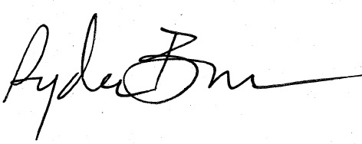

Ryder Bunce
Environmental Technical Services Manager
Division of Onsite Water and Wastewater Services

